Technical Design for
file transfer replacement project


Store to Corporate integration Hub
Version 002

Contents
1 Document Review & Sign-off 3
1.1 Document Properties 3
1.2 Revision History 3
1.3 Document Approvers 3
1.4 Supporting Documents 3
2 Introduction 4
2.1 Purpose 4
2.2 Responsibility for this Document 4
2.3 Document Scope 4
2.4 Audience 4
3 Overview 5
3.1 Business and Technical Overview 5
4 Design 6
4.1 Interface/Service Pattern 6
4.2 Sequence Diagram 6
4.3 RTI Components 7
4.3.1 RTI Instructions 7
5 Operations 8
5.1 Restart/Recover conditions 8
6 Assumptions 8
- Document Review & Sign-off

Document Properties
Author | Creation Date | Last Updated | Version
Geoff Lyle | 05/04/2011 | 05/25/2011 | 001

Revision History
Ver. | Date | Description | Author
001 | 05/04/2011 | Initial Draft | Geoff Lyle
002 | 05/25/2011 | Updates | Geoff Lyle

Document Approvers
Name | Role | Signature | Sign-off Date
Jeremy Sena | SysRepublic
Geoff Lyle | SysRepublic
Ned Bilkic | SOA Solution Architect
Soeren Ahrens | SOA Program Lead
Abhi Srivastava | SOA PD Lead

Supporting Documents
Document Title | Document Type | Author | Date | Location
Technical_Design_Ross_File_Transfer_Solution_Overview_v2 | Technical Design | Geoff Lyle | 5/5/2011
- Introduction

Purpose
The purpose of this document is to define the essential characteristics of Store to RTI Corporate Integration Hub transfers. The document will identify the communication internal to RTI and define the flow of data between the Store ISP and the Hub. Ross application and Store Systems teams are expected to reach a mutual agreement on the interface design prior to technical design.

Responsibility for this Document
Sysrepublic will own this document and subsequently is responsible for updates and versioning. All changes and additions are subject to review prior to sign off.

Document Scope
This document will cover, at a detailed level, the design as described by the functional requirements for communication between Store Systems and ROSS systems integration. The document details the solution design and features the Integration components to be used for Stores to interface with the Corporate Integration Hub. The document will also feature the common exception handling service for the RTI processes which manage the transfer of files between the two environments.

This document is intended to provide the technical design pattern for all Stores to Hub transfers. Specific interface configuration sheets will detail the requirements for each individual file transfer.

The Sysrepublic team would use this document in the subsequent phases to build the integration components.

Audience
This document is intended for persons who seek to understand the high level agreement between the RTI component development team and consumers of the data which passes between of the RTI Corporate Integration Hub and RTI Agents installed on the Store ISP. The audience includes:

• Project Managers
• Functional Analysts
• Application Architects
• Software Developers
• Testing Analysts
• Production Support Personnel
- Overview

Business and Technical Overview
The purpose of this document is to provide a design pattern for any Store Initiated transfer to back to corporate systems. This process defines how the store will push files to the Integration hub. This document does not cover the process which moves a file form the Hub to the destination System. This document does not make any assumptions as to the 'business objective or purpose' of the files being transferred, this information will form part of the end to end design of the business application utilizing this file transfer solution.

The pattern described here will enable a repeatable mechanism to push files to the integration Hub via an https stream which moves the file(s) from the store ISP to a storage location on the Hub.

The pattern will cater for the following transmission options
- Scheduled Pre Process rules to initiate the transfer
- Event based monitoring to initiate transfers
- Flexible file renaming
- Compression
- Encrypted https streaming between systems

The pattern described in this document will either be scheduled; with each store to hub transfer configured using a preprocessing rule to define the contextual information for the transfer. A generic DDS adapter will be sued to execute the store hub transfer once the prerequisites of the initiating rue lave been met.

Each file or archive can be regarded as a 'transmission' from store to hub. Each transmission will be logged for audit purposes and alerting will be implemented to highlight non-transmission of data.

The file transfer solution will be built using the Sysrepublic RTI technology platform. RTI will provide the data movement and logging engine for all transmissions. For more information on RTI please see the 'RTI Help' documentation.

The following set example interfaces will be supported by the Pattern described in this Document:

PCI Security
EDW Store Data
RMS Store Data
Zip Code Survey

- Design

Interface/Service Pattern
Service would follow point to point pattern and frequency of file transfers will be scheduled.

Sequence Diagram
Normal Flow Sequence Diagram

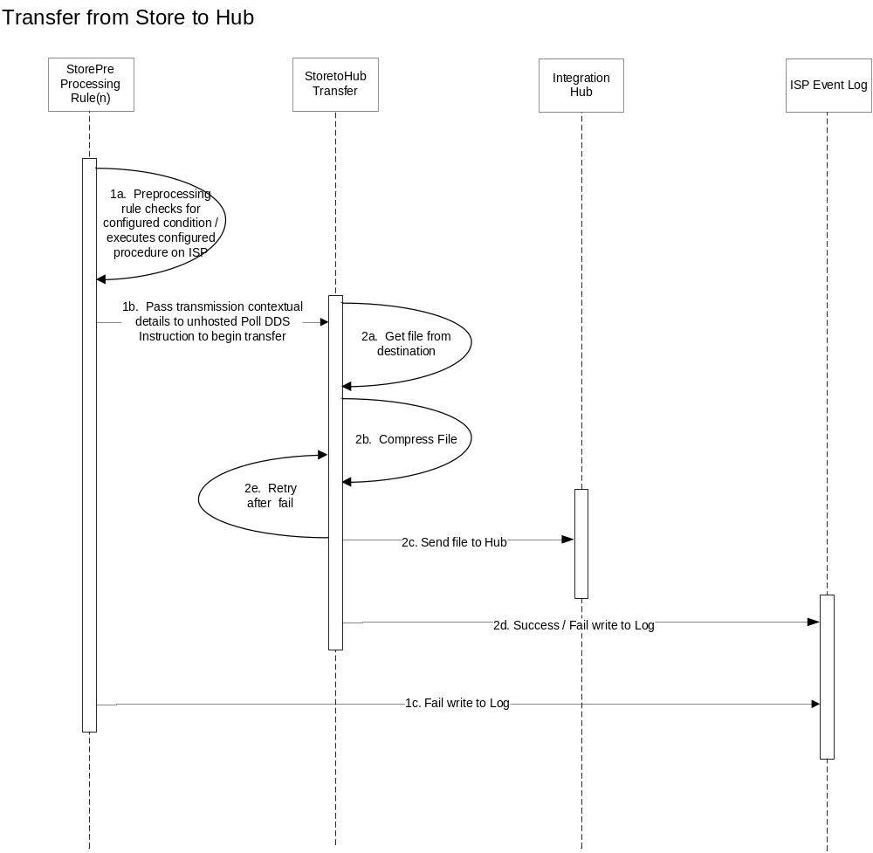

Normal Sequence Diagram Walkthrough
Normal Sequence # | Event | Component Invoked | Output | Alternate flow sequence#
1a. | At a scheduled time a Hosted Instruction on the RTI Store Agent will run a preprocessing rule to initiate a store to hub transfer | StorePreProcessingRule(n) | Pre Process completed
1b. | Pass contextual details of the transmission to an unhosted send instruction on the store agent | StorePreProcessingRule(n) | Unhosted instruction invoked
1c. | On fail write to ISP event log | StorePreProcessingRule(n) | Error logged to event log
2a | File adapter gets file from source directory | Store to Hub Transfer | Call transform step
2b | Transform step internal to the instruction Compresses file(s) | Store to Hub Transfer | Call destination step
2c. | Https stream to Hub is initiated | Store to Hub Transfer | Https stream
2d. | Write success of fail to the ISP event log using the event log adapter in RTI | Store to Hub Transfer | Event added to log
2e. | Retry after fail | Store to Hub Transfer | Initiate unhosted send

RTI Components

RTI Instructions
The following RTI instruction templates will be required for the Hub to Store Service:
Instruction Name | Type | Details
StorePreProcessRule(n) | Scheduled | Scheduled instruction runs a pre process to define contextual information and execute any pre processing before initiating a new transfer
StoretoHubTransfer | Unhosted Receive | UnHosted Instruction to Push files to DSS when initiated by a preprocessing rule

Operations

Restart/Recover conditions
Failure Point | Description | Resubmit Functionality | Process Type | Guiding Principle | Support Procedure | Frequency
StorePreProcess  Rule(n) | Fails to Complete Preprocess | None | N/A | Store Issue | ? | Low
StoretoHub  Transfer | Fails to complete https stream | Error occurs and Retry / restart transmission | Https / Transfer | Infrastructure Issue | ? | Low

Assumptions
ID | Description
1 | StorePostProcessingRule(n)RTI instruction is a variable component the specific instructions required will be determined by the details interface configuration sheets
2 | Processing errors which occur at the store will be written to the Store’s ISP event application log
3 | RTI is able to retry am unhosted instruction by the having the instruction invoke itself, may require a preprocessing step if not able to configure as diagramed
4

